**23CSE111**

**OBJECT-ORIENTED PROGRAMMING**

**LAB REPORT**



**Department of Computer Science Engineering**

**Amrita School of Computing**

**Amrita Vishwa Vidyapeetham, Amaravati Campus**

**VERIFIED BY: NAME: P.PRANATHI**

**ROLL NO: AV.SC.U4CSE24239**

**WEEK 01**

**PROGRAM-1:**

**AIM:** Download and Install Java Software

**PROCEDURE:**

**Step 1: Download JDK 21**

1. Open your web browser and go to the Oracle JDK Downloads page
2. Scroll down to the Java SE Development Kit 21 section.
3. Choose the Windows x64 Installer version.
4. Click on Download, then Wait for the download to complete**.**

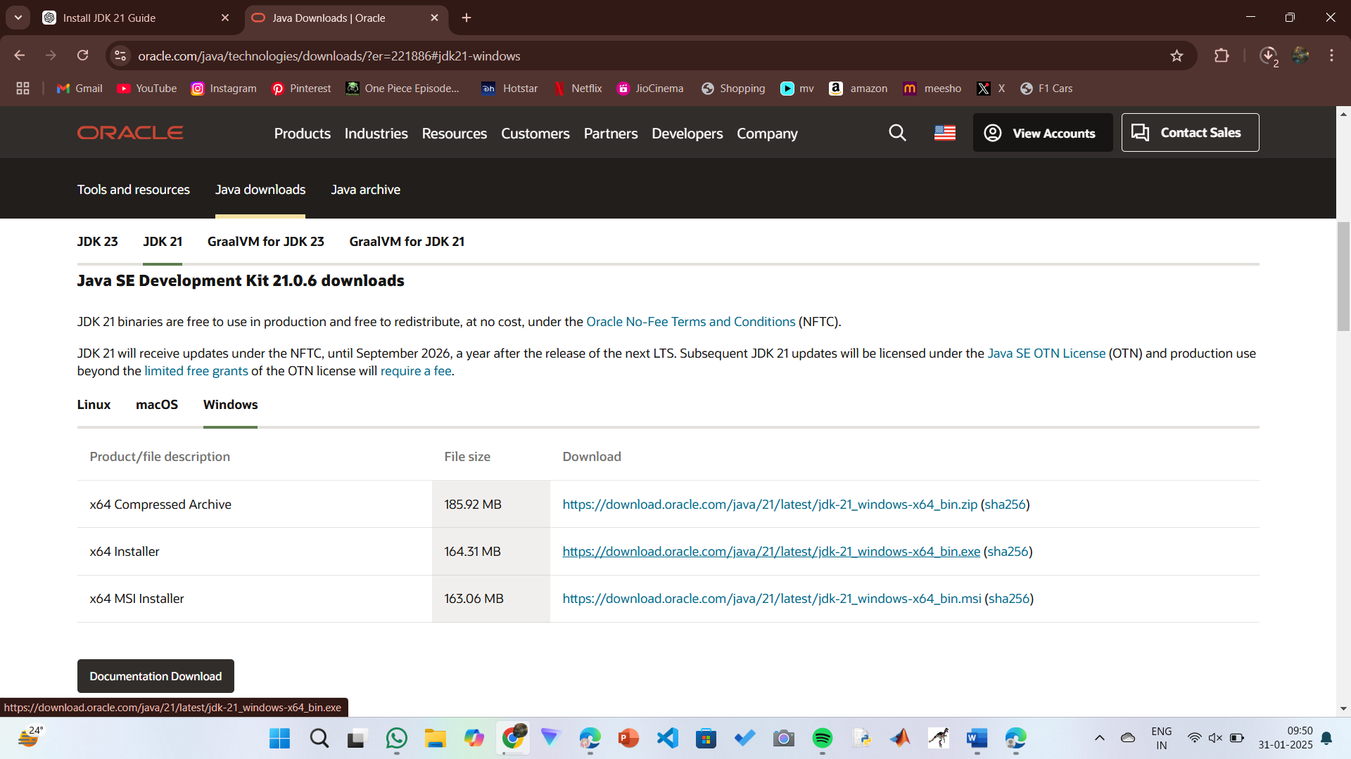

**Step 2:** **Install JDK 21**

1. Locate the downloaded jdk-21_windows-x64_bin.exe file.
2. Double-click to launch the installer.
3. Click Next on the setup wizard.
4. Choose the installation path (default is C:\Program Files\Java\jdk-21).
5. Click Next, then click Install.
6. Wait for the installation to complete.
7. Click Close once the installation is finished.

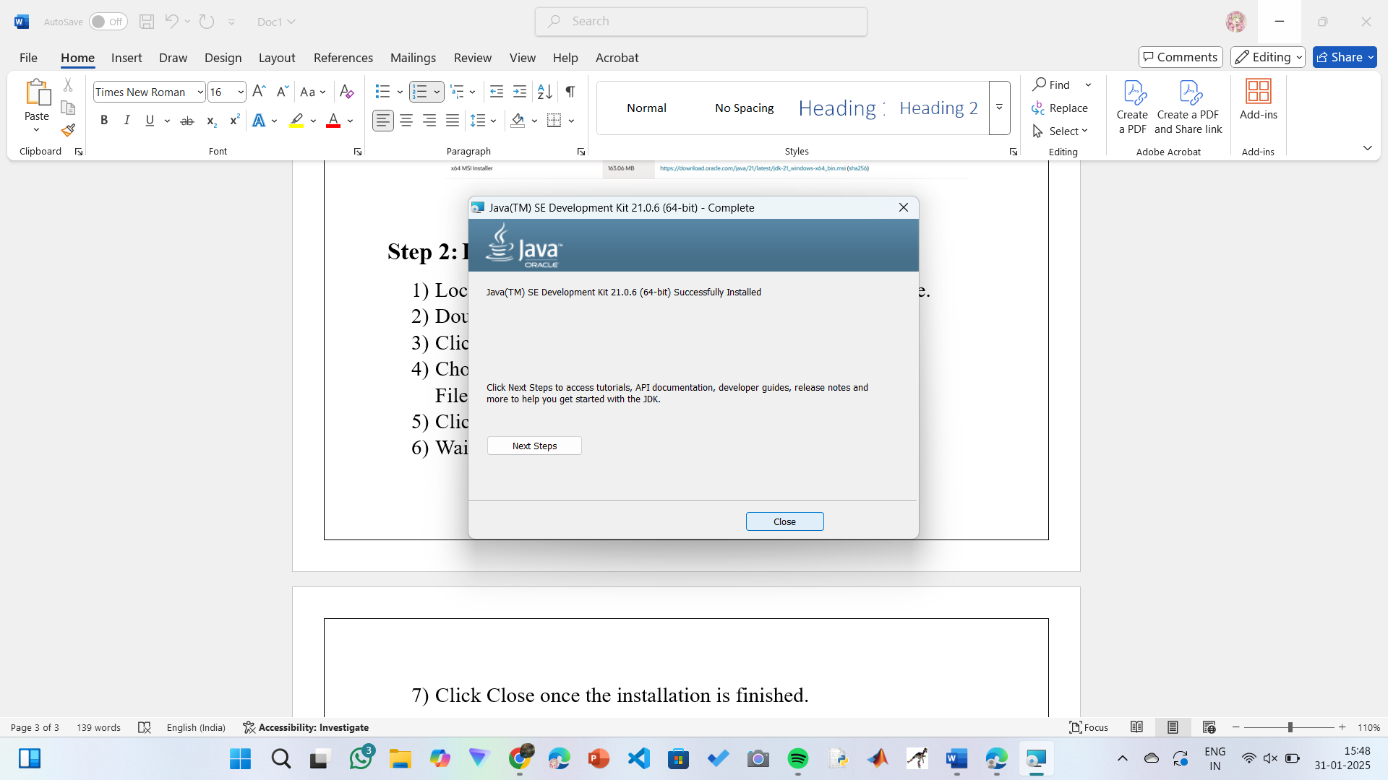

**Step 3: Setting up the path**

1) Go to “Windows C” Drive on Desktop

2) Choose Program Files, select Java, then JDK 21, then select Bin.

3) Select and copy the path at the address bar.

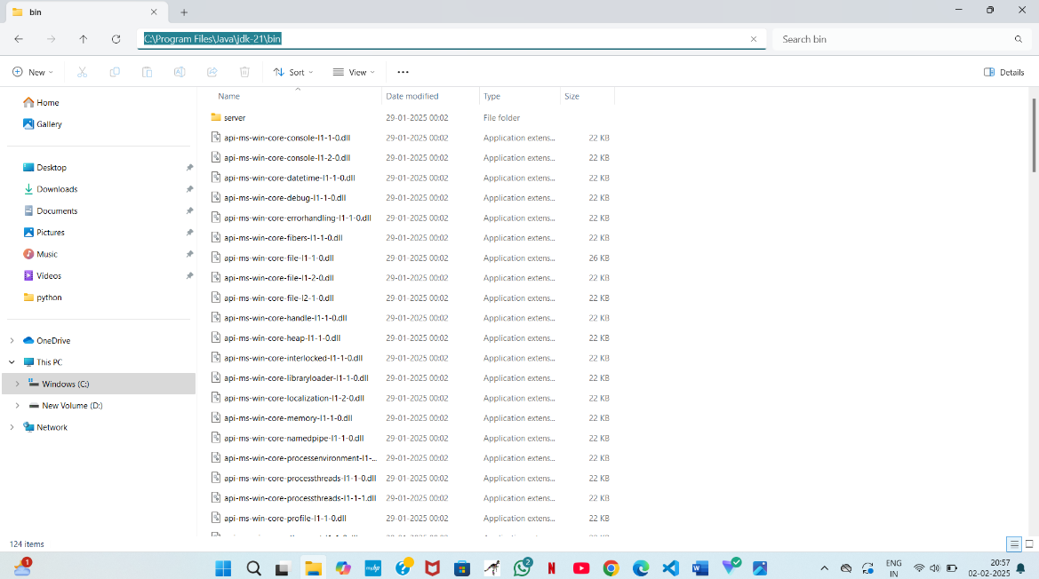

**Step 4: Open System Properties**

1. Press Windows + R, type sysdm.cpl , and click Ok.
2. The System Properties window will open.
3. Navigate to the Advanced tab.
4. Click on Environment Variables at the bottom.

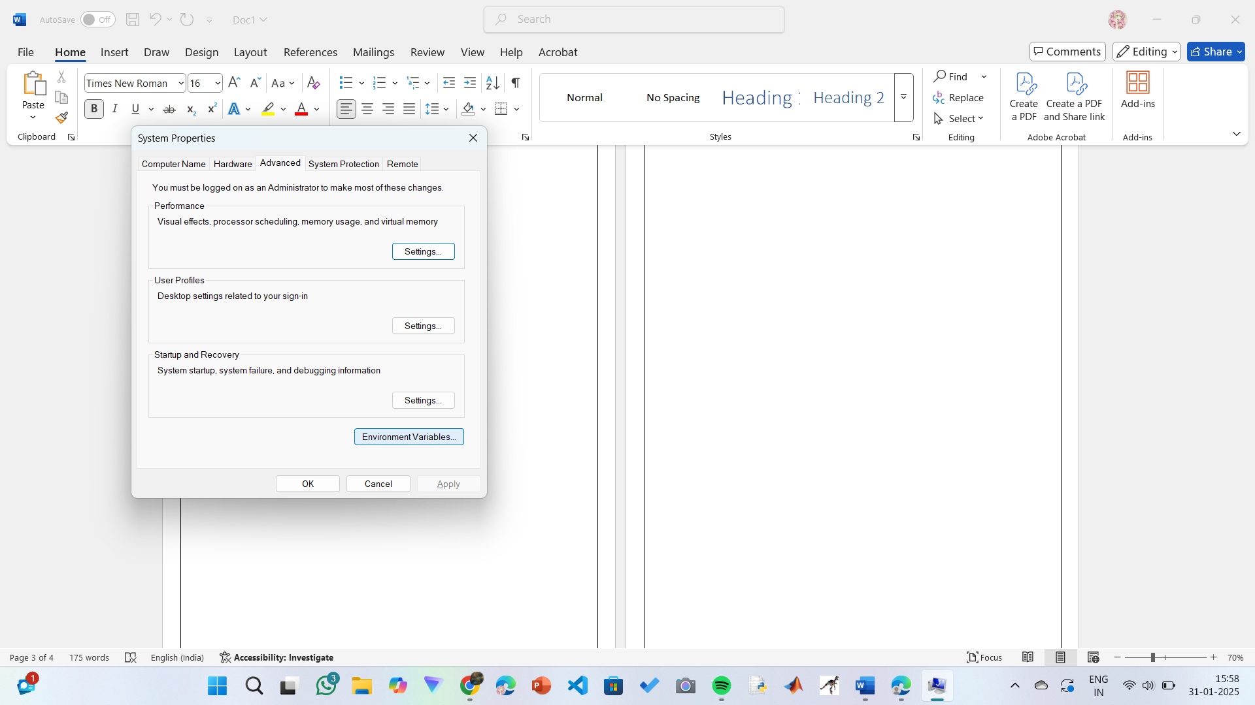

**Step 5: Set JAVA_HOME**

1)Under System Variables, click New.

2)Set the Variable name as JAVA_HOME.

3)Set Variable value as C:\Program Files\Java\jdk-21 (or your installation path).

4)Click OK.

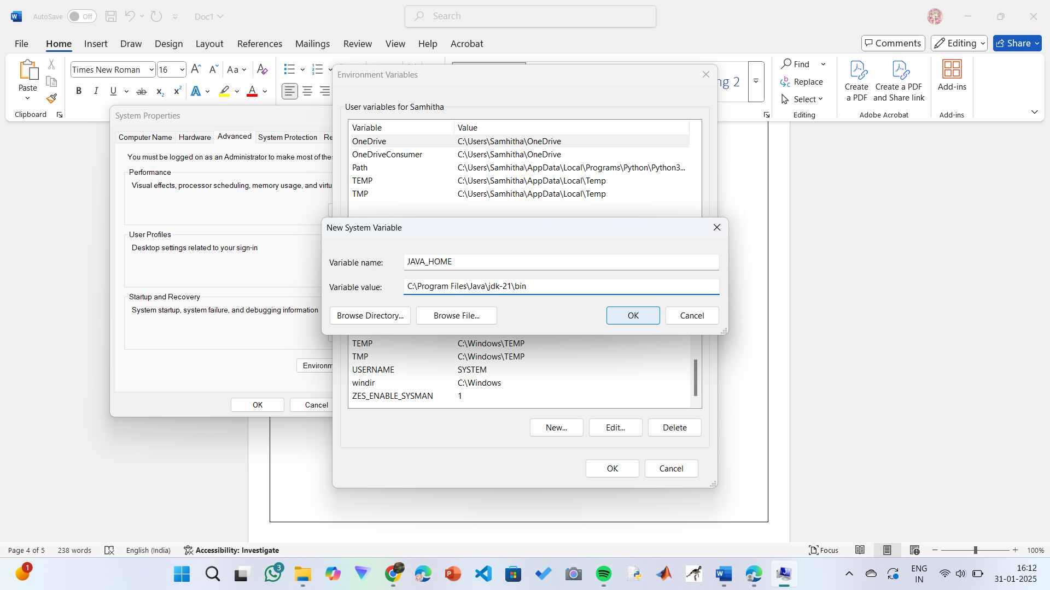

**Step 6: Update PATH Variable**

1)In System Variables, find Path and click Edit.

2)Click New and add: C:\Program Files\Java\jdk-21\bin

3)Click OK to save.

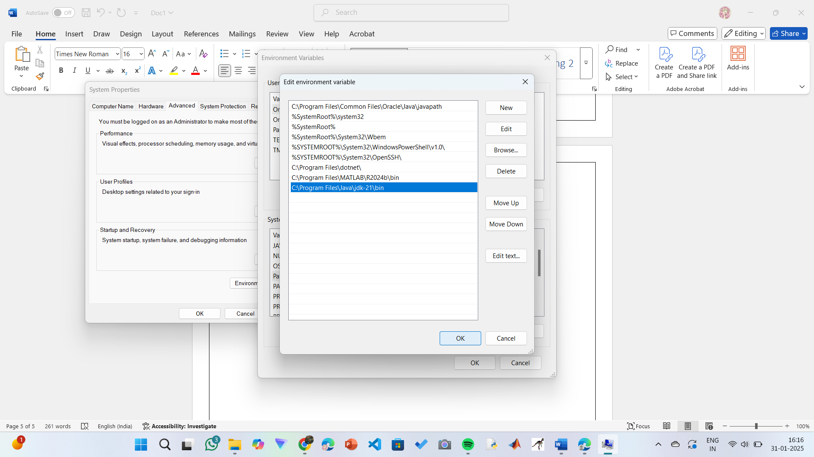

**Step 7:Verify Installation**

1. Open Command Prompt.
2. Type the following command: **java --version** and press Enter.

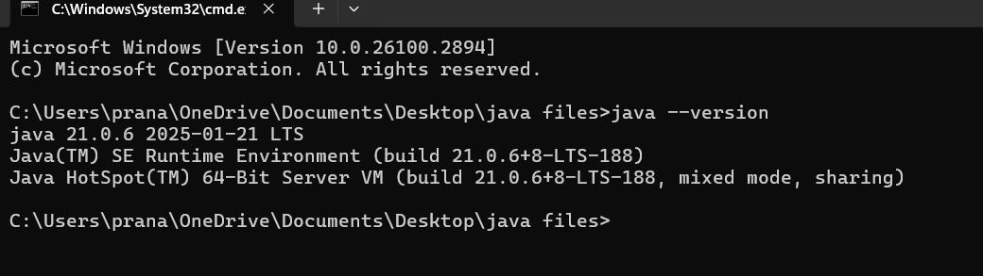

1. To check the java compiler type: **javac –version.**



**PROGRAM-2:**

**AIM:** Write a Java program to print the message “Welcome to Java Programming.”

**CODE:**

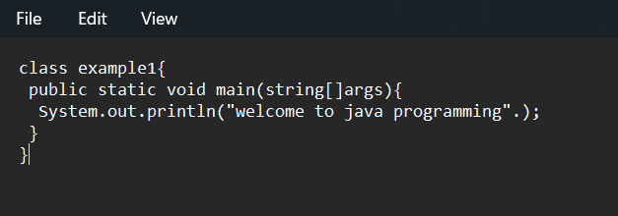

**OUTPUT:**

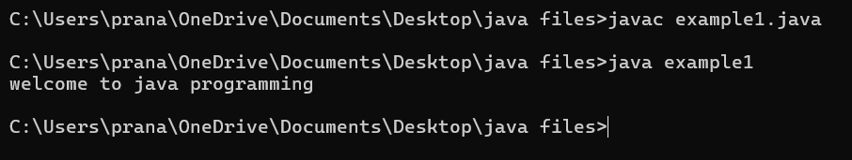

ERROR TABLE:

|  |  |
| --- | --- |
| **Code Error** | **Code rectification** |
| 1)writing small ‘s’ in place of ‘S’  In system.out.println()  2)not keeping the “(strings)” gives error . | 1)code is rectified by keeping capital ‘S’  2)keep the strings so that the output can be printed. |

**Important points:**

1)make sure that there were no syntax errors.

2)follow the syntaxs , in this code we learn that system.out.println()

Is used to print the statements line after line.

**PROGRAM-3:**

**AIM:** Write a Java Program that prints Name, Section , Roll No of a student.

**CODE:**

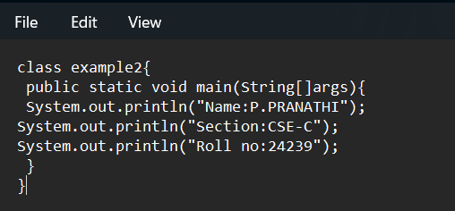

**OUTPUT:**

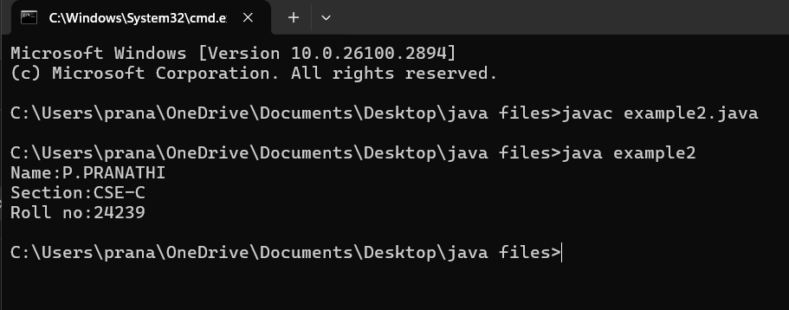

**ERROR TABLE:**

|  |  |
| --- | --- |
| Code Error | Code rectification |
| 1)writing small ‘s’in place of’S’ In system.out.println()  2)missing semicolon can give the error. | 1)code is corrected by keeping capital ‘S’  2)giving semicolon leads to give the correct the code. |

**Important points: 1)** The area of a rectangle is calculated using the formula: area = L * B, where  
L represents the length of the rectangle,  
B represents the breadth of the rectangle.

**2)**It is essential to ensure that all expressions and conditions inside the for loop are written correctly.

**PROGRAM-4:**

**AIM:** Write a java program to Calculate area of rectangle.

**CODE:**

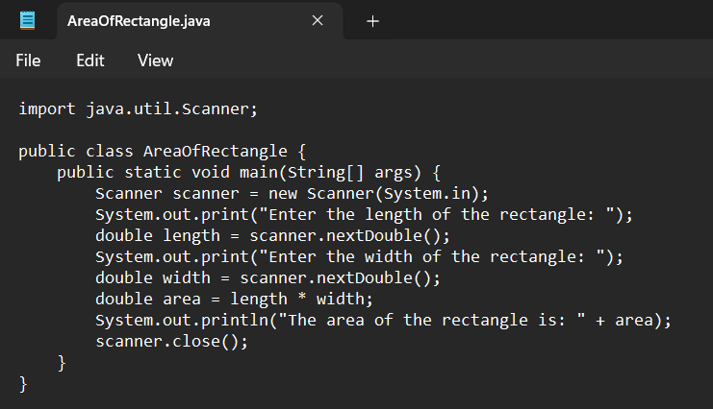

**OUTPUT:**

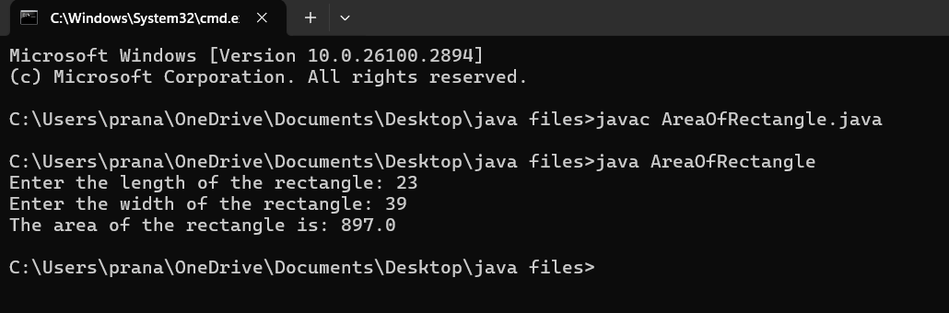

**ERROR TABLE:**

|  |  |
| --- | --- |
| Code Error | Code rectification |
| 1)writing small “s”in place of”S”  In (system.out.println()).  2)not giving strings to the name and section  3)not specifying the data type of the variable clearly  Ex: String area is incorrect | 1)code is corrected by keeping capital “S”.  2)Giving strings to name and section  3)mention the data type of the variable clearly  Ex: double area |

**IMPORTANT POINTS:**

1. The formula to calculate Simple Interest is: (P * T * R) / 100, where:
   * P: Principal amount
   * R: Rate of interest
   * T: Time period
2. The Scanner class allows for reading input from the keyboard.
3. import java.util.Scanner signifies:
   * Import: Informs the Java compiler that a specific class or package is being utilized in the code.
   * java.util: This is the package containing utility classes, including the Scanner class.
4. double is a data type used to represent floating-point numbers, which are numbers with decimals.

**PROGRAM-5:**

**AIM:** Write a java program to Convert temperature celsius into fahrenheit

**CODE:**

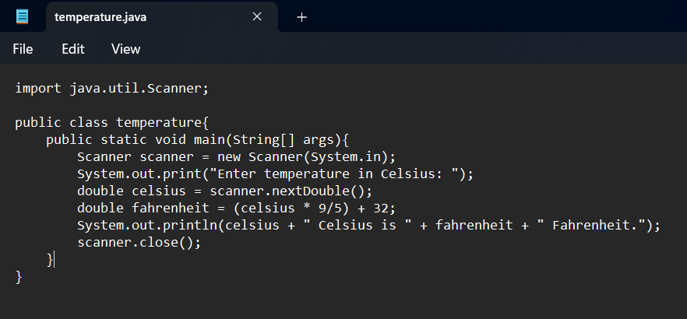

**OUTPUT:**

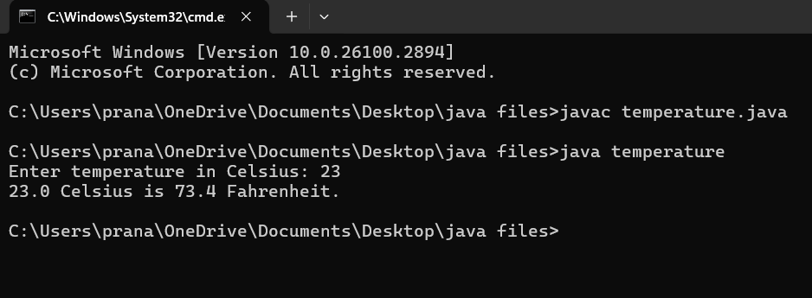

**ERROR TABLE:**

|  |  |
| --- | --- |
| Code Error | Code rectification |
| 1)writing small “s”in place of”S”  In system.out.println()  2)not giving strings to the name and section | 1)code is corrected by keeping capital “S”  2)Giving strings to name and section |

**IMPORTANT POINTS:**

1.The formula to convert a Celsius to Fahrenheit is

Fahrenheit = (Celsius*9/5)+32.

2.The line “Scanner input = new Scanner(System.in),” tends to create a new Scanner object named “input” that reads input from the standard input stream (System.in), like keyboard.

**PROGRAM-6:**

**AIM:**Write a java program for factorial of a number n.

**CODE:**

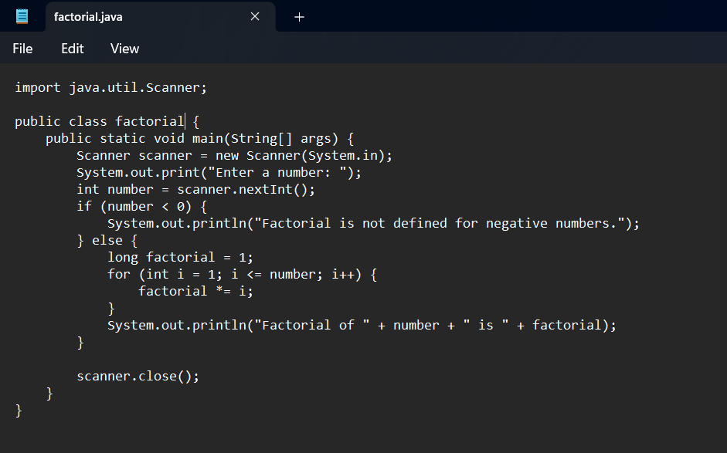

**OUTPUT:**

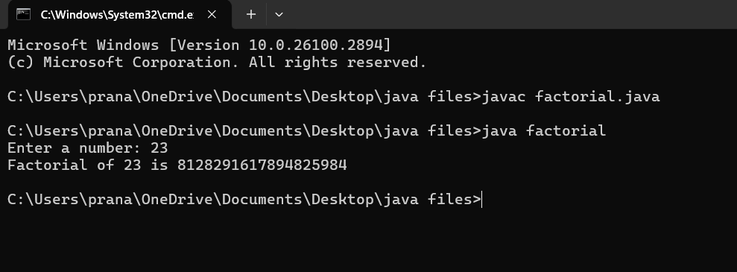

**ERROR TABLE:**

|  |  |
| --- | --- |
| Code Error | Code rectification |
| 1)writing small ‘s’ in place of ’S’  In (system.out.println().)  2)not giving strings to the name and section. | 1)code is corrected by keeping capital ‘S’.  2)Giving strings to name and section. |

**IMPORTANT POINTS:**

1. int is a data type used to store integer values, and it does not support floating-point numbers.
2. Inside the parentheses of a for loop, the data refers to:
   * Initial expression
   * Test expression
   * Update expression
3. \**factorial = I* is shorthand for factorial = factorial * I.

**PROGRAM-7:**

**AIM:** Write a java program for Fibonacci of a number

**CODE:**

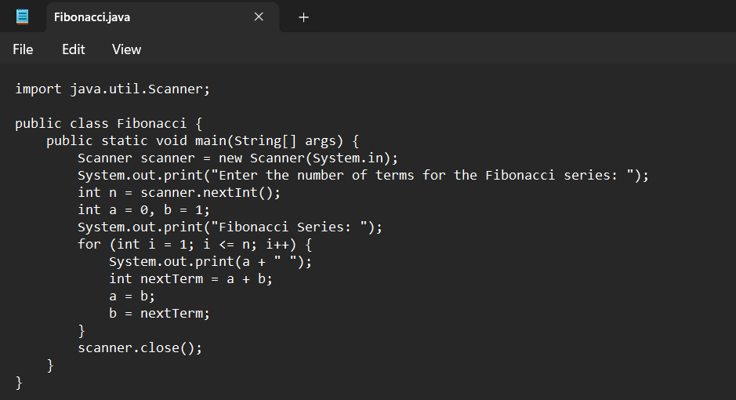

**OUTPUT:**

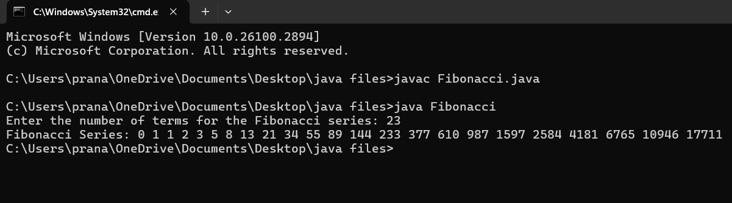

**ERROR TABLE:**

|  |  |
| --- | --- |
| Code Error | Code rectification |
| 1)writing small “S”in place of”S”.In system.out.println()  2)not declaring the variables can give error | 1)code is rectified by keeping capital “S”  2)declaring variables before usage is important. |

**IMPORTANT POINTS:**

1. The process continues until the specified conditions are satisfied, repeating a certain number of times.
2. In the Fibonacci sequence, the value of the second variable is assigned to the first, and the sum is stored in the second variable.

**PROGRAM-8:**

**AIM:** Write a java program for area of the triangle using Heron’s formulae.

**CODE:**

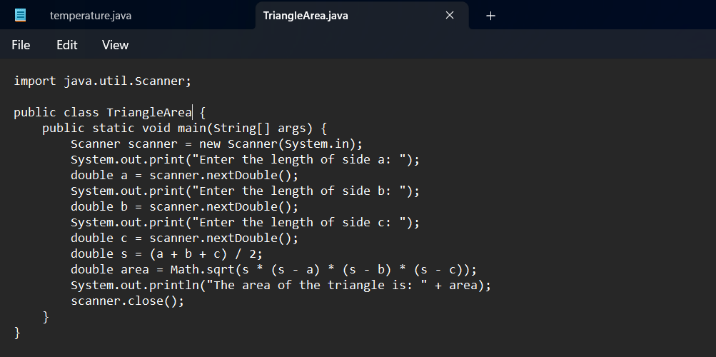

**OUTPUT:**

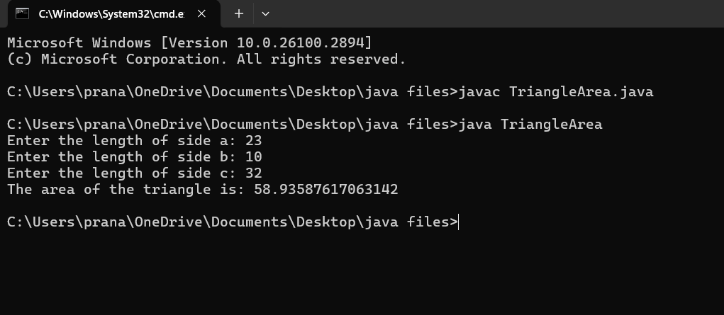

**ERROR TABLE:**

|  |  |
| --- | --- |
| Code Error | Code rectification |
| 1)writing small “S”in place of”S”  In system.out.println()  2)incorrect formulae may leads to correct output but it is incorrect answer | 1)code is rectified by keeping capital “S”  2)check formulae correctly. |

**IMPORTANT POINTS:**

1.Heron’s formula for finding area of the triangle is:

S = (a +b +c)/2

Where S is the semi-perimeter of the triangle.

Now the area formula is:

Area = sqrt(s*(s-a)*(s-b)*(s-c)).

**WEEK -3:**

**PROGRAM 1:**

**1.AIM:** To create java program with following instructions **:**

1.Create a class with name Car

2.Create four attributes named car_color,car_brand, fuel_type, mileage

3.Create these methods named start(),stop(),service()

4.Create the objects named car, car1,car2

**PROGRAM:**

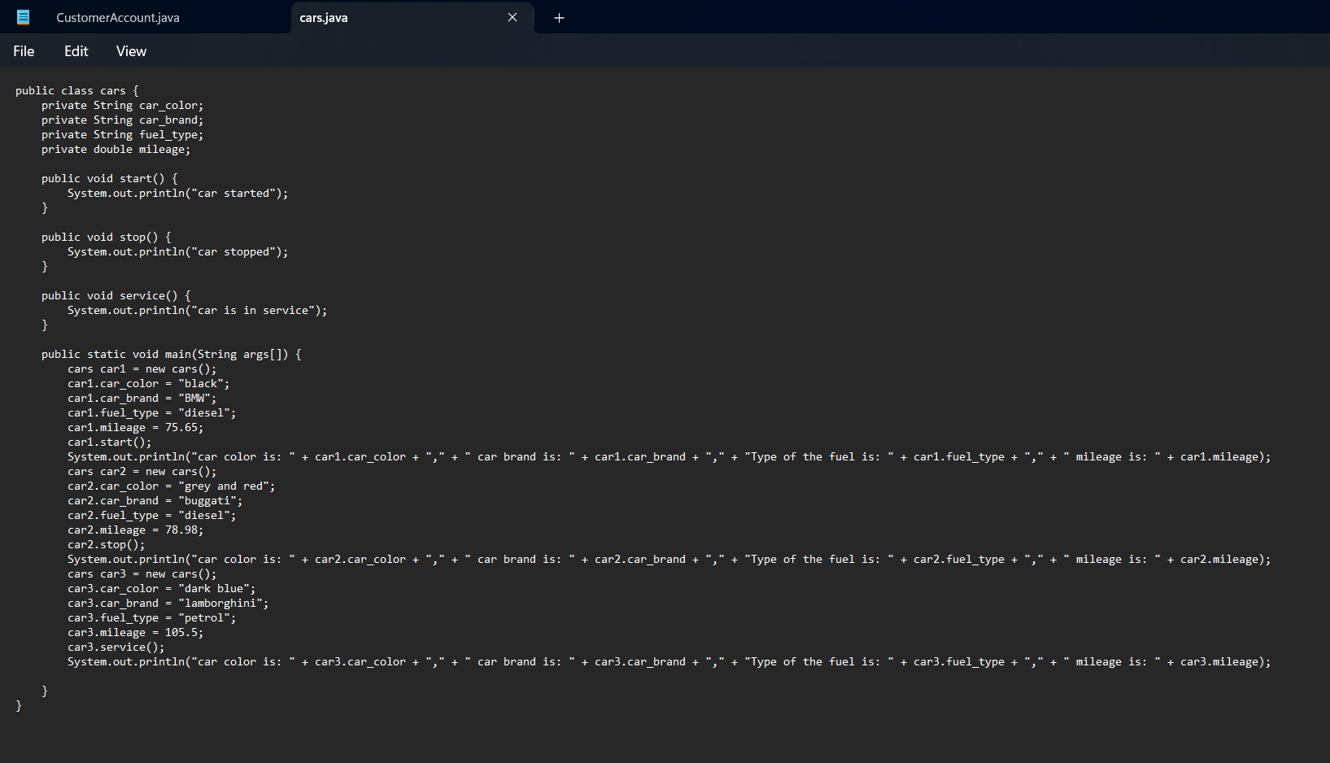

**OUTPUT:**

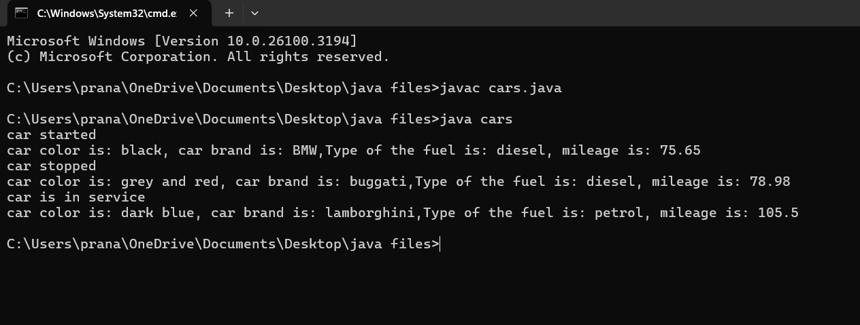

**ERROR TABLE:**

|  |  |
| --- | --- |
| Code Error | Code rectification |
| 1. Not putting the semi-colon; after calling the method . 2. After Start, Stop, Service not giving the parenthesis ( ). | 1. keep semi-colon after calling the method in the code. 2. After every method, put the parenthesis ( ). |

**NEGATIVE CASE;**

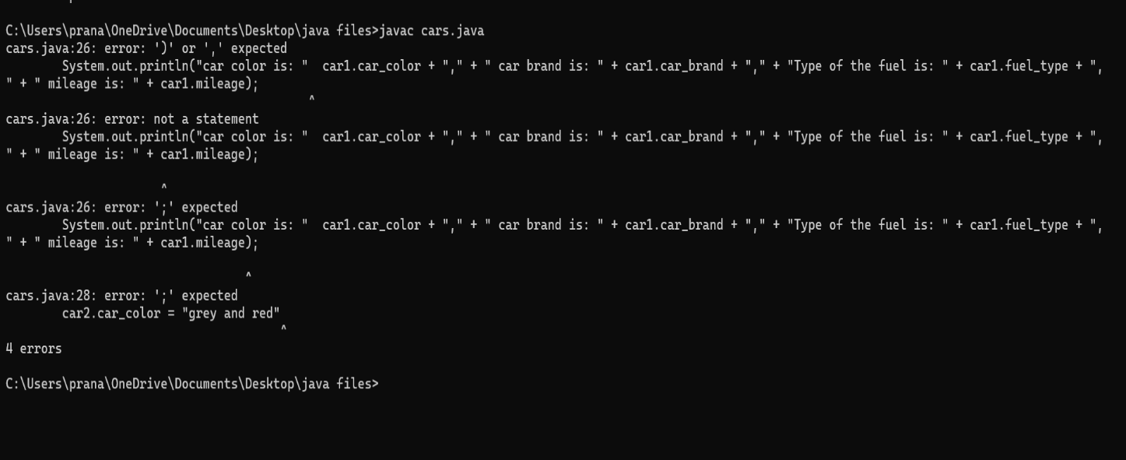

**IMPORTANT POINTS:**

1. We need to define the method correctly before using it.
2. The statement **"public void start()"** shows that we are creating a method to execute a function.
3. When we call a method, whatever is inside it gets executed and displayed as output.
4. The values inside the function are known as objects, and we can create multiple objects as needed.

**CLASS DIAGRAM:**

+---------------------------------+

| Cars |

+---------------------------------+

| - car_color: String |

| - car_brand: String |

| - fuel_type: String |

| - mileage: double |

+---------------------------------+

| + start(): void |

| + stop(): void |

| + service(): void |

+---------------------------------+

**PROGRAM2:**

**2.AIM: To create a class BankAccount with methods deposit() and withdraw() . create two subclasses savingsaccount and checkingaccount override the withdraw () method in each subclass to impose different withdrawal limits and fees**

**PROGRAM:**

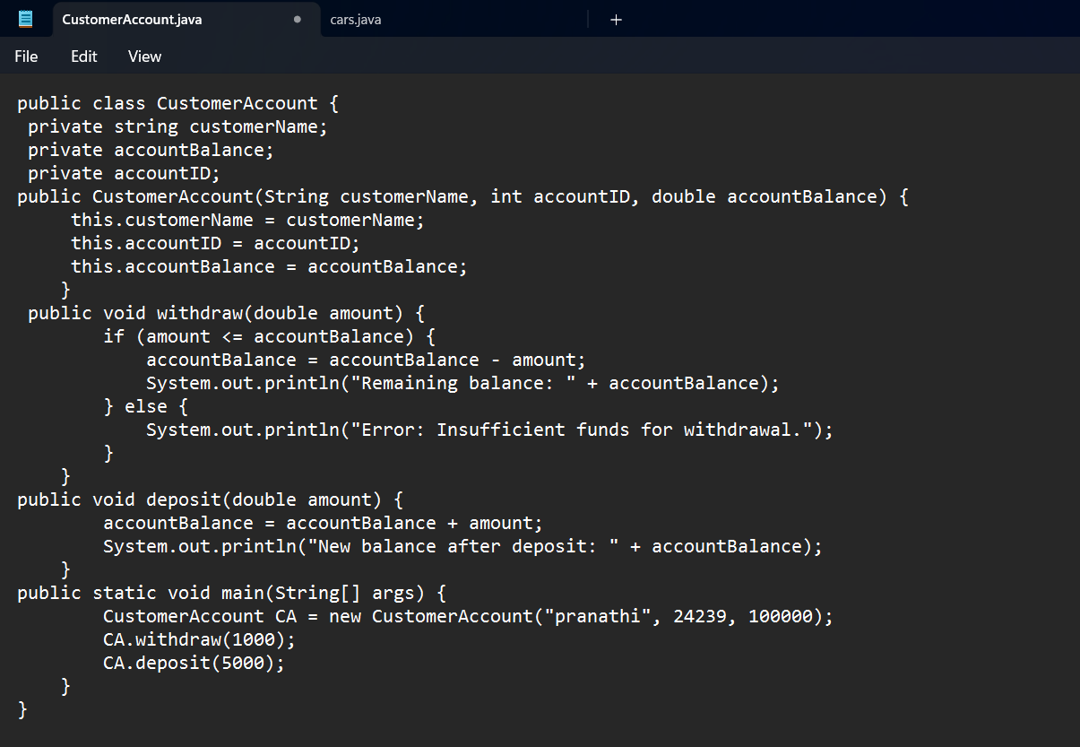

**OUTPUT:**



**NEGATIVE CASE:**

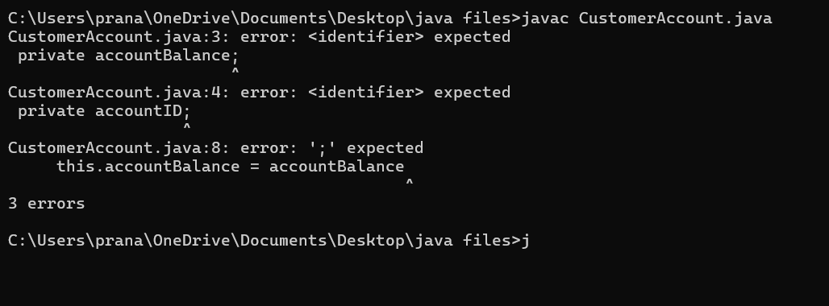

**IMPORTANT POINTS:**

1. The condition inside the if statement must be correct.
2. It explains that if the withdrawal money is less than the money in the bank account, then we can withdraw the amount.

**CLASS DIAGRAM:**

+--------------------------------------------------------------------+

| CustomerAccount |

+--------------------------------------------------------------------+

| - customerName: String |

| - accountID: int |

| - accountBalance: double |

+--------------------------------------------------------------------+

| + CustomerAccount(String, int, double) |

| + withdraw(double): void |

| + deposit(double): void |

+--------------------------------------------------------------------+

**WEEK -4**

**PROGRAM – 1:**

**AIM:** Write a java program with class named “book”, the class should contain various attributes such as title, author, year of publication it should also contain a constructor with parameters which initializes, title, author, and year of publication.

Create a method which displays the details of the book and display the details of two books.

**CODE:**

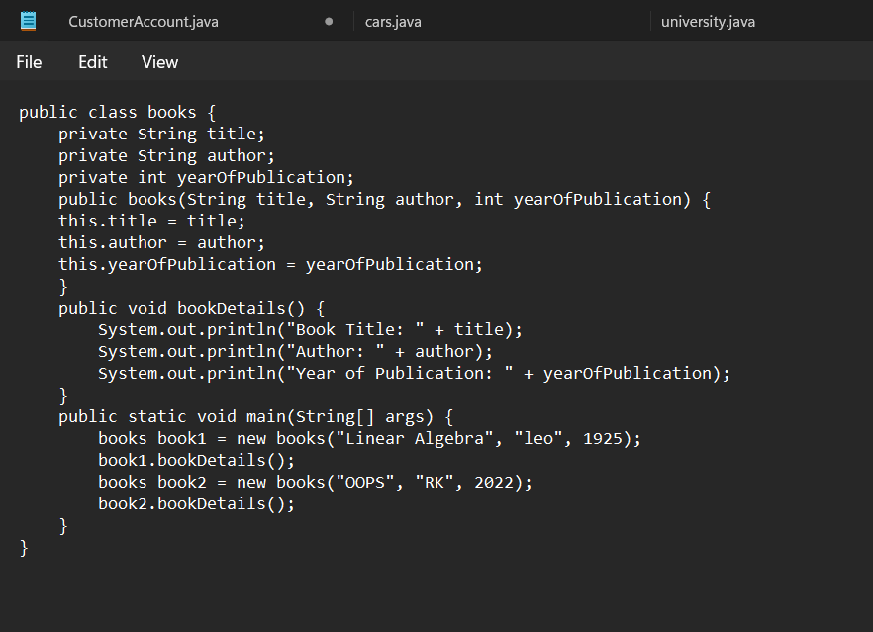

**OUTPUT:** 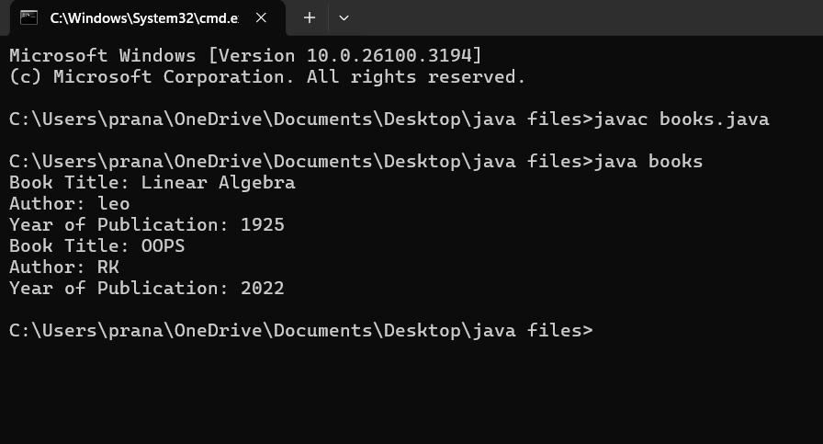

**ERROR TABLE:**

|  |  |
| --- | --- |
| **Code Error** | **Code rectification** |
| 1. Not defining the function in a file. 2. Two public class files should not be saved in the same file. | 1. To call the method we must define a function in a file. 2. Two public class files should be saved in different files. |

**NEGATIVE CASE:**

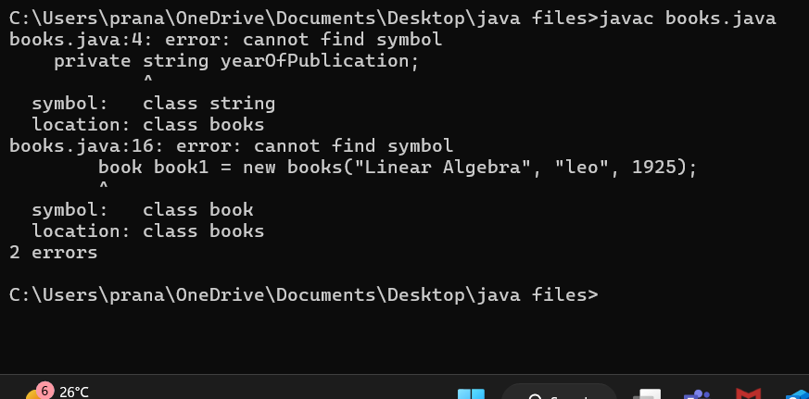

**IMPORTANT POINTS:**

1. While defining two classes for a code, we must be sure that we save both the classes in separate files.
2. While defining a method we should also define a function to call that method.

**CLASS DIAGRAM:**

+------------------------------------------+

| books |

+--------------------------------------------+

| - title: String |

| - author: String |

| - yearOfPublication: int |

+-------------------------------------------+

| + books(String, String, int) |

| + bookDetails(): void |

+--------------------------------------------+

**PROGRAM – 2:**

**AIM:** Create a java Program with class named myclass with static variable count of int type, initialized to zero and a constant variable “pi” of type double initialized to 3.14 as attributes of the class, ow define a constructor for “myclass” that increments the count variable each time an object of my class is created (count++), finally print the final values of count and pi variables create three objects.

**CODE:**

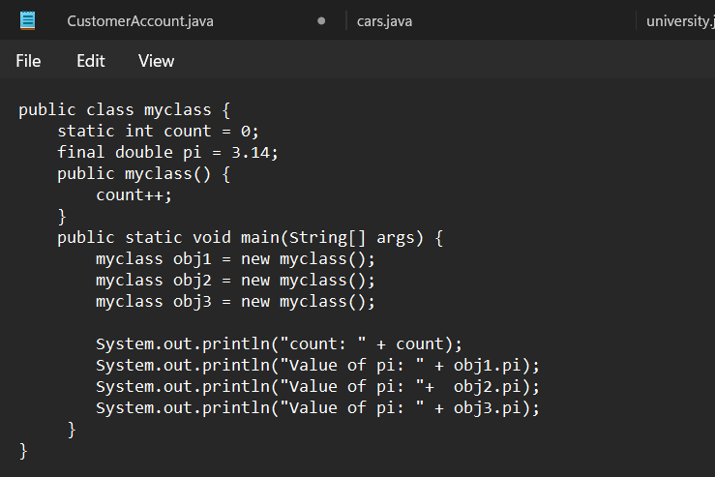

**OUTPUT:**

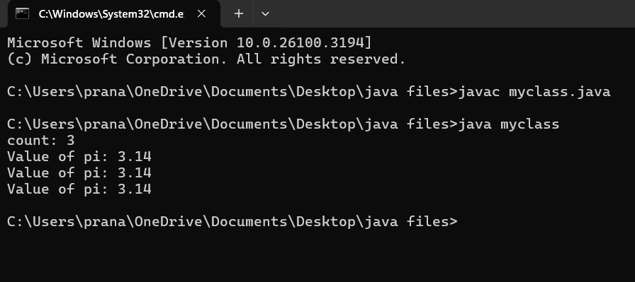

**ERROR TABLE:**

|  |  |
| --- | --- |
| **Code Error** | **Code rectification** |
| 1. Not Putting the semi-colon after calling a function, 2. Not giving the indentation properly. | 1. Put the semi-colon after calling a function. 2. All the indentation must be correct to run the code correct. |

**NEGATIVE CASE:**

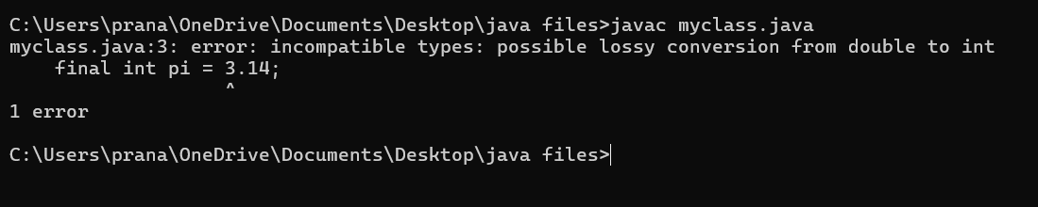

**IMPORTANT POINTS:**

1) Before setting the final value, we should first assign an initial value to the variable.

2) The main goal is to increase the count based on the number of objects created, meaning the count goes up as more objects are added.

**CLASS DIAGRAM:**

+----------------------------------+

| myclass |

+----------------------------------+

| - count: int (static) |

| - pi: double (final) |

+----------------------------------+

| + myclass() |

| + main(String[]): void |

+-----------------------------------+

**WEEK-5**

**PROGRAM-1:**

**AIM:** Create a calculator using the operations including addition, subtraction, multiplication, and division using multi-level inheritance and display the desired output. Hint: collect required variables using super class, Create each class for a parameter and each class must contain a method.

**CODE:**

class calculator {

protected double a, b;

public calculator(double a, double b) {

this.a = a;

this.b = b;

}

}

class Sum extends calculator {

public Sum(double a, double b) {super(a, b); }

public double sum() {

return a + b;

}

}

class Subtraction extends Sum {

public Subtraction(double a, double b) { super(a, b); }

public double sub() {

return a - b;

}

}

class Multiplication extends Subtraction {

public Multiplication(double a, double b) { super(a, b); }

public double mult() {

return a * b;

}

}

class Division extends Multiplication {

public Division(double a, double b) { super(a, b); }

public double div() {

if (b != 0) {

return a / b;

} else {

System.out.println("Error");

return Double.NaN;

}

}

}

class Final extends Division {

public Final(double a, double b) { super(a, b); }

public void displayResults() {

System.out.println("Addition: " + sum());

System.out.println("Subtraction: " + sub());

System.out.println("Multiplication: " + mult());

System.out.println("Division: " + div());

}

}

import java.util.Scanner;

public class allcalculator {

public static void main(String[] args) {

Scanner input = new Scanner(System.in);

System.out.println("Enter a number: ");

double a = input.nextDouble();

System.out.println("Enter b number: ");

double b = input.nextDouble();

Final calc = new Final( a, b);

calc.displayResults();

System.out.println("The output was printed");

input.close();

}

}

**OUTPUT:**

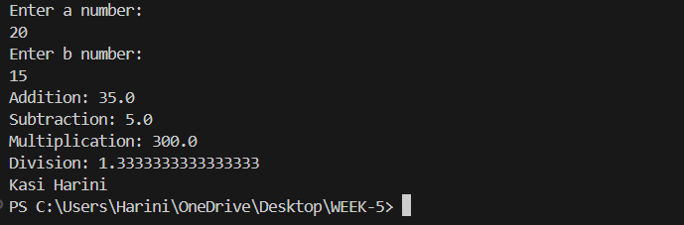

**CLASS DIAGRAM:**

**+----------------+**

**| calculator |**

**+----------------+**

**| - a: double |**

**| - b: double |**

**+----------------+**

**| + calculator() |**

**+----------------+**

**▲**

**│**

**+-------------------+--------------------+**

**▲ ▲**

**| |**

**+---------+ +---------------+**

**| Sum | | Subtraction |**

**+---------+ +-----------------+**

**| + sum() | | + sub() |**

**+-----------+ +----------------+**

**▲ │**

**| ▼**

**+------------------+ +----------------+**

**| Multiplication | | Division |**

**+-------------------+ +----------------+**

**| + mult() | | + div() |**

**+--------------------+ +----------------+**

**▲**

**│**

**+----------------------+**

**| Final |**

**+-----------------------+**

**| + displayResults() |**

**+-----------------------+**

**ERROR TABLE:**

|  |  |
| --- | --- |
| **Code Error** | **Code rectification** |
| 1. not providing the return method correctly. 2. Not mentioning super to obtain the super class constructor. | 1. After declaring methods, we must provide the return method correctly. 2. To obtain the super class we need to mention super. |

**NEGATIVE CASE:**

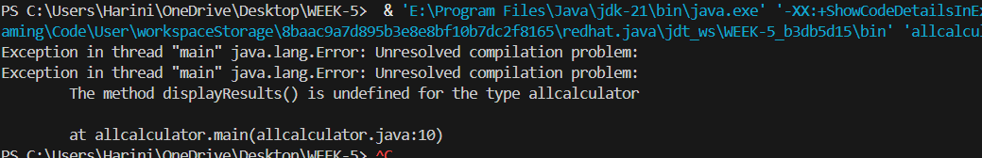

**IMPORTANT POINTS:**

1. **To get the inputs from the user we use import java.util.Scanner; this is a package.**
2. **Scanner class is used to get the user input.**
3. **in java.util.Scanner, the java.util is a package while Scanner is a class of the java.util package.**
4. **to import a whole package, end the sentence with an asterisk sign(*).**

**PROGRAM-2**

**AIM:** A vehicle rental company wants to develop a system that maintains information about different types of vechicles available for rent the company rents out cars and bikes, and they need a program to store details about each vehicle, such as brand and speed( should be in super class)

1. cars should have an additional property: no.of doors
2. Bikes should have a property indicating whether they have gears or not.
3. The system should also include a function to display details about each vehicle and indicate when a vehicle is starting.
4. Every class should have a constructor
5. Question:
6. Which oops concept is used in the above program
7. If the company decides to add a new type of vehicle, Truck, how would you modify the program?
8. Truck should include an additional property capacity (in tons)
9. Create a showTruckdetails() method to display the truck’s capacity.
10. Write a constructor for Truck that initializes all properties
11. Implement the truck class and update the main method to create a Truck object and also create an object for car and bike sub classes Finally, display the details.

**CODE:**

public class vehicle {

public String brand;

public int speed;

public vehicle(String brand, int speed) {

this.brand = brand;

this.speed = speed;

}

public void start() {

System.out.println(brand + " is starting");

}

public void showDetails() {

System.out.println("Brand: " + brand);

System.out.println("Speed: " + speed + " km/h");

}

}

class Car extends vehicle {

private int noOfDoors;

public Car(String brand, int speed, int noOfDoors) {

super(brand, speed);

this.noOfDoors = noOfDoors;

}

public void showDetails() {

super.showDetails();

System.out.println("Number of Doors: " + noOfDoors);

}

}

class Bike extends vehicle {

private boolean hasGears;

public Bike(String brand, int speed, boolean hasGears) {

super(brand, speed);

this.hasGears = hasGears;

}

public void showDetails() {

super.showDetails();

System.out.println("Has Gears: " + (hasGears ? "Yes" : "No"));

}

}

class Truck extends vehicle {

private int capacity;

public Truck(String brand, int speed, int capacity) {

super(brand, speed);

this.capacity = capacity;

}

public void showTruck() {

super.showDetails();

System.out.println("Capacity: " + capacity + " tons");

}

}

public class rent {

public static void main(String[] args) {

Car car = new Car("Buggati",140,8);

Bike bike = new Bike("Duke",250, true);

Truck truck = new Truck("TATA", 100, 2);

System.out.println("Car Details");

car.start();

car.showDetails();

System.out.println("Bike Details");

bike.start();

bike.showDetails();

System.out.println("Truck Details");

truck.start();

truck.showTruck();

System.out.println("the output was printed");

}

}

**OUTPUT:**

**CLASS DIAGRAM:**

**+---------------------+**

**| vehicle |**

**+----------------------+**

**| - brand: String |**

**| - speed: int |**

**+----------------------+**

**| + vehicle() |**

**| + start() |**

**| + showDetails() |**

**+-----------------------+**

**▲**

**│**

**+-------------------------+-----------------------------+**

**▲ ▲ ▲**

**| | |**

**+---------------+ +--------------+ +------------+**

**| Car | | Bike | | Truck |**

**+---------------+ +---------------+ +-------------+**

**| - noOfDoors: int | | - hasGears: bool | |- capacity: int |**

**+---------+ +-----------------+ +----------------+**

**| + Car() | | + Bike() | | + Truck() |**

**| + showDetails() | | + showDetails() | | + showTruck() |**

**+----------------+ +----------------+ +--------------+**

**▲**

**|**

**+----------------+**

**| rent |**

**+----------------+**

**| + main() |**

**+----------------+**

**ERROR TABLE:**

|  |  |
| --- | --- |
| **Code Error** | **Code rectification** |
| 1. Declaring two superclasses inside the same file. 2. Not declaring the variable using ‘this’ keyword inside the constructor. | 1. Make two separate files to save the two super classes. 2. Declare the variable using this keyword to run the program. |

**NEGATIVE CASE:**

**IMPORTANT POINTS:**

1. a constructor helps in initializing an object that doesn't exist.
2. a method performs functions on pre-constructed or already developed objects.
3. a double method can represent more decimal point numbers than float method.
4. the void keyword in java is used to specify that a method does not return any value. it is a return type that indicates the method performs a function and doesn't produce a result.

Answer:

The oops concepts used in the above program are:

Inheritance, encapsulation, polymorphism, abstraction.

To add a new vehicle type truck we need to create a truck class that will:

* Include an additional property capacity (in tons).
* Implement a showtruckdetials() method to display the truck's capacity.
* Implement a constructor for the truck class to initialize all its properties.